**Describe any layered process you are familiar with similar to the OSI model**

A similar model to the OSI Model is the TCP/IP model the only difference between the two is while the OSI model has 7 layers the TCP/IP has 5 layers.

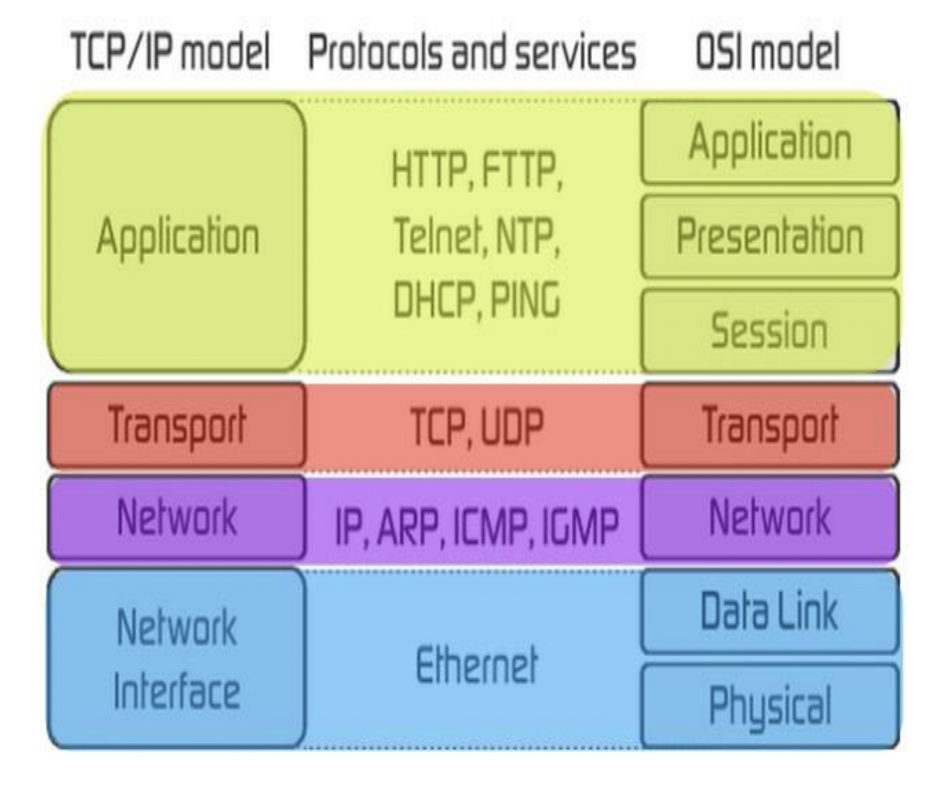

*A picture of the TCP/IP model vs OSI model*

**What is TCP/IP?**

TCP/IP stands for Transmission control protocol /internet protocol and is a suite of communication protocols used to interconnect network devices on the internet. TCP/IP is also used as a communications protocol in a private computer network (an [intranet](https://whatis.techtarget.com/definition/intranet) or extranet). It functions as an abstraction layer between internet applications and the routing and switching fabric.

Common TCP/IP protocols include the following:

* Hypertext Transfer Protocol (HTTP) handles the communication between a web server and a web browser.
* [HTTP Secure](https://searchsoftwarequality.techtarget.com/definition/HTTPS) handles secure communication between a web server and a web browser.
* File Transfer Protocol handles transmission of files between computers.

### **The 4 layers of the TCP/IP model**

TCP/IP functionality is divided into four layers, each of which includes specific protocols:

1. **The application layer** provides applications with standardized data exchange. Its protocols include HTTP, FTP, Post Office Protocol 3, Simple Mail Transfer Protocol and Simple Network Management Protocol. At the application layer, the payload is the actual application data.
2. **The transport layer** is responsible for maintaining end-to-end communications across the network. TCP handles communications between hosts and provides flow control, multiplexing and reliability. The transport protocols include TCP and User Datagram Protocol, which is sometimes used instead of TCP for special purposes.
3. **The network layer**, also called the *internet layer*, deals with packets and connects independent networks to transport the packets across network boundaries. The network layer protocols are IP and Internet Control Message Protocol, which is used for error reporting.
4. **The physical layer**, also known as the *network interface layer* or *data link layer*, consists of protocols that operate only on a link -- the network component that interconnects nodes or hosts in the network. The protocols in this lowest layer include Ethernet for local area networks and Address Resolution Protocol.